Create a Job like this:

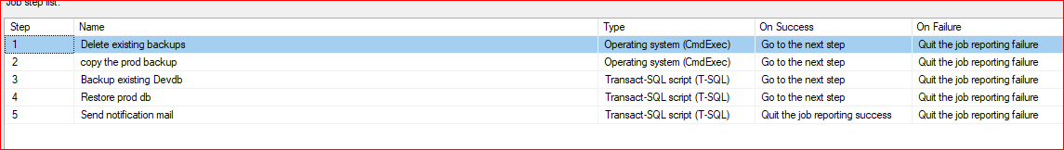

**Step 1:delete existing backups**

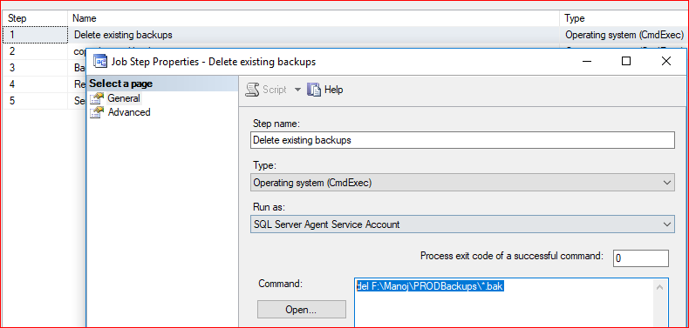

del F:\Manoj\PRODBackups\*.bak

**step2: copy the prod backup**

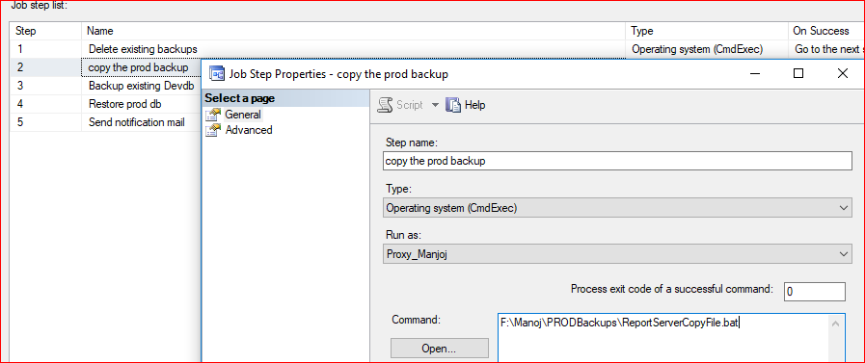



Open the above file, in notepad and customize this according to your system

**Step 3: Backup existing Devdb**

Before restore, Take the existing db as backup(safe side, if you want)

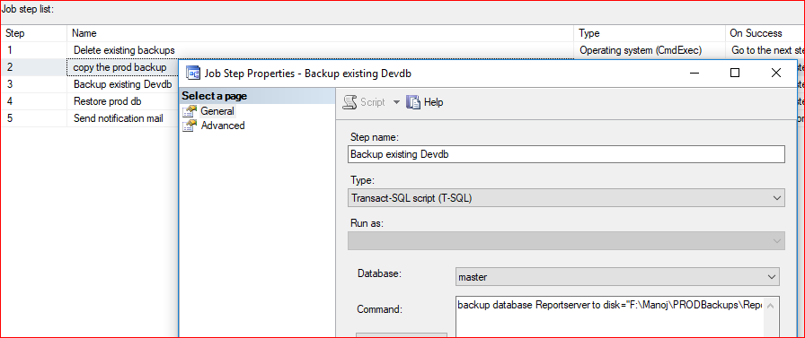

backup database Reportserver to disk=''F:\Manoj\PRODBackups\Reportserver_dev.bak''

**step 4: Restore prod db**

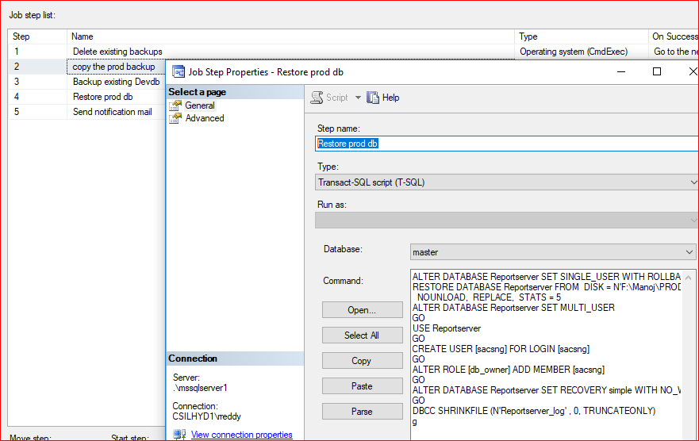

ALTER DATABASE Reportserver SET SINGLE_USER WITH ROLLBACK IMMEDIATE

RESTORE DATABASE Reportserver FROM DISK = N'F:\Manoj\PRODBackups\Reportserver.bak' WITH FILE = 1,

NOUNLOAD, REPLACE, STATS = 5

ALTER DATABASE Reportserver SET MULTI_USER

GO

USE Reportserver

GO

CREATE USER [sacsng] FOR LOGIN [sacsng]

GO

ALTER ROLE [db_owner] ADD MEMBER [sacsng]

GO

ALTER DATABASE Reportserver SET RECOVERY simple WITH NO_WAIT

GO

DBCC SHRINKFILE (N'Reportserver_log' , 0, TRUNCATEONLY)

**Step 5: Send notification mail**

Keep notification by using sp_sendmail